**Change the Volume Size of an Instance.**

* Creating the new volume which we want to add to an instance and clicking on **create volume**

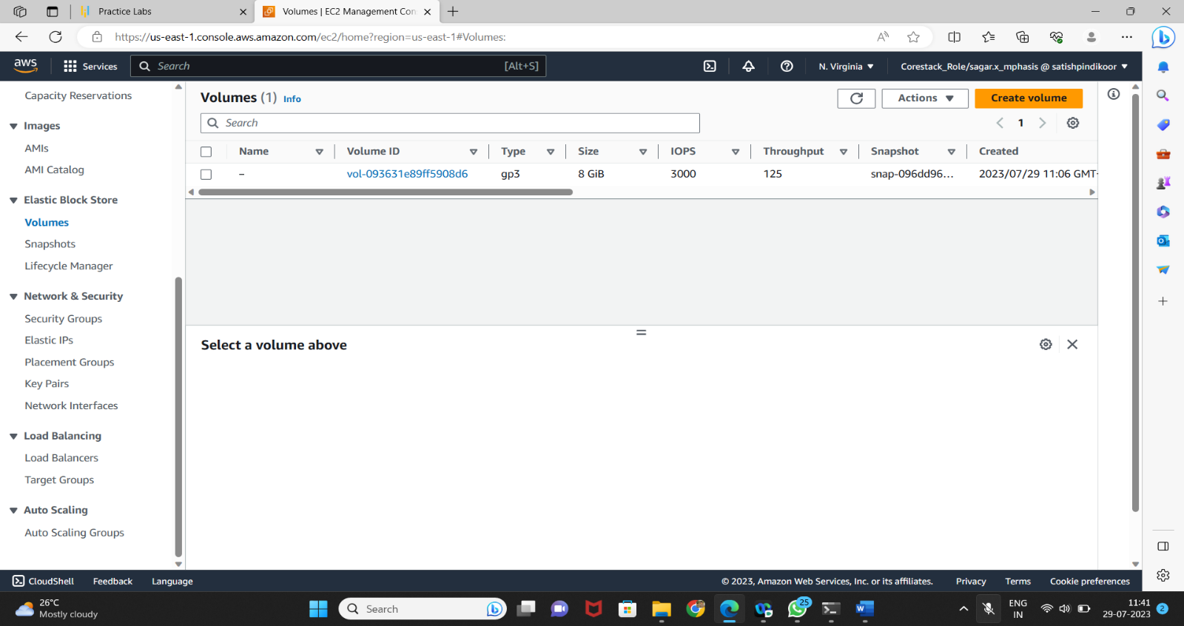

* Validating the Availability zone of the EC2 instance with which you want to add volume

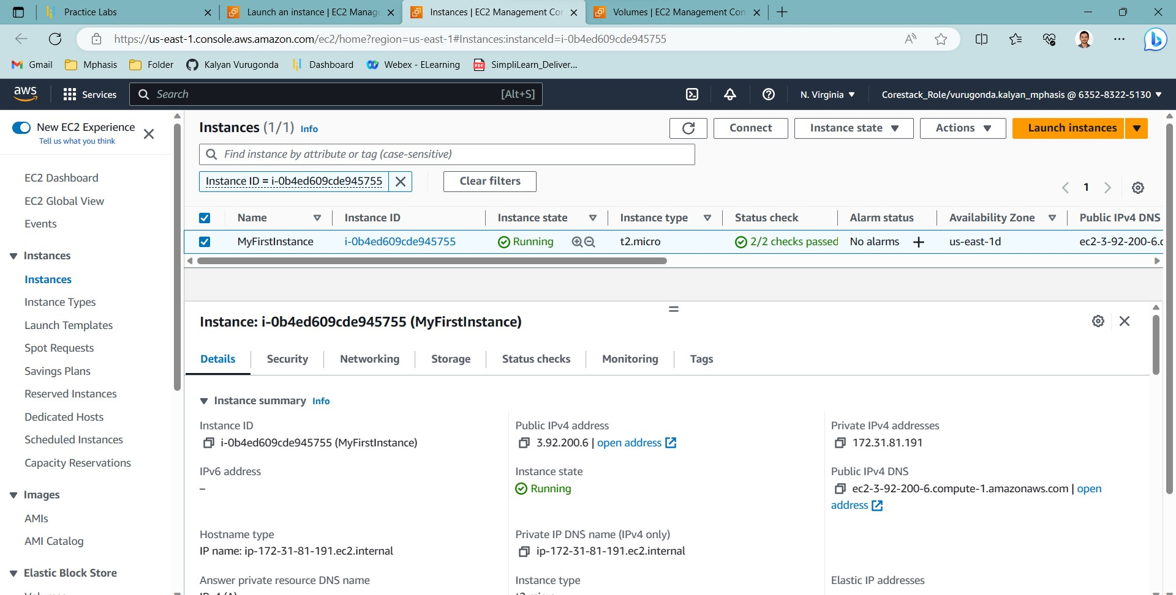

* Providing type, size, availability zone, and snapshot name on the **create volume** tab

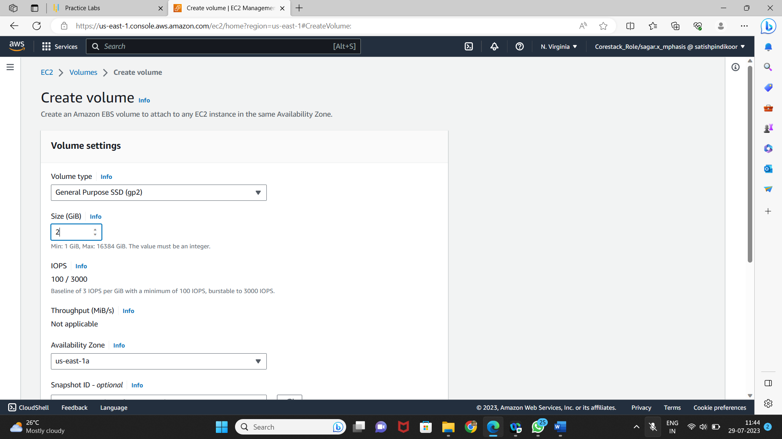

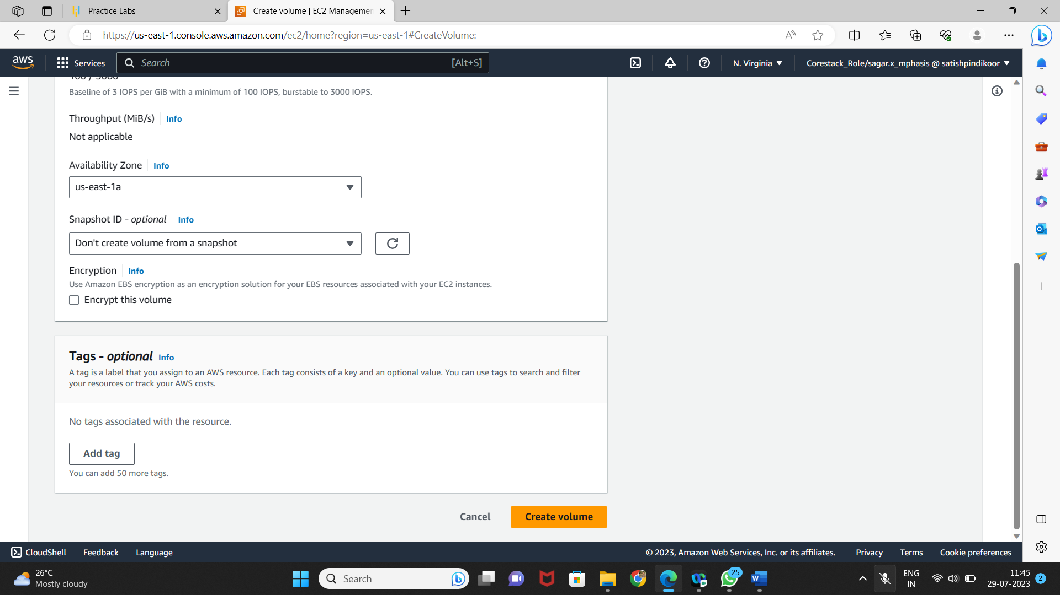

* Selecting newly created volume and clicking on the action to attach the volume to the instance

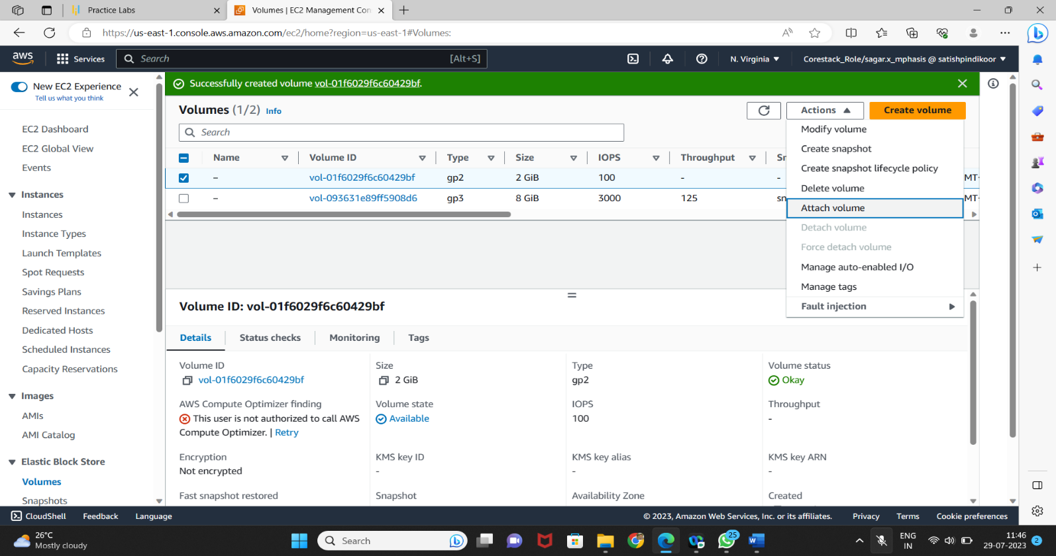

* Selecting the instance of the same availability zone and attaching the volume in pop

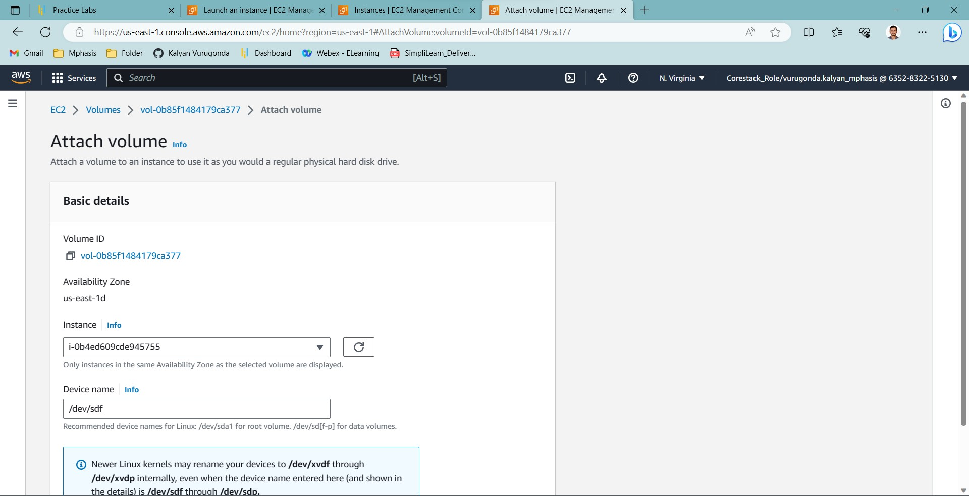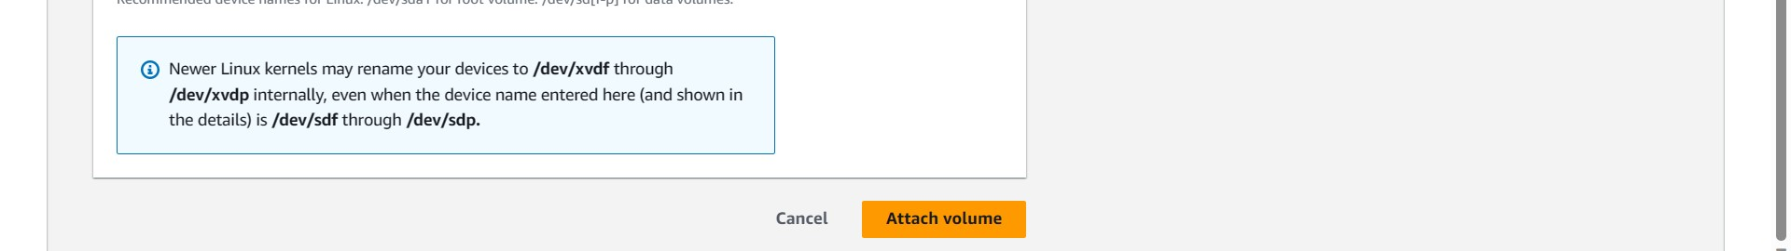

* Verifying the instance by adding one more device to the block device

